Title: Election System

Aim: To create a voting system using the concepts learnt in C

language.

Abstract: Digital voting system is one of the easy process to vote.

In this process, the user must enter the number of people

voting. Then the first person to vote must enter their age.

If it is below 18, the process ends saying the person is not

eligible to vote. Else the person is asked to enter his/her

name and then voterid. Then the list of candidates

participating is displayed and the person is asked to vote

candidate from the list. The process continues in the same

for the rest of the people voting. For each person

completing the process the total votes per candidate till

then is displayed.

Technologies used: C programming language, Codeblocks code

editor, Windows 10 operating system.

Sample scenario: The project begins with taking the required

details from the user. Based on the values, the

output is given.

Assumptions taken: Large database, Graphical user Interface, C

programming language, Windows 10 OS,

Codeblocks code editor, Input is taken from

scanf(); and printf(); is used to give instructions

and Output is provided by printf(); function.

Details handled: The process begins from main() function. For each

person the process is repeated using for loop.

Structure person is declared before main()

containing name and voterid. Structure is called

and input is taken if the user’s age is above 18

and then vote is taken from the user. Vote count

per candidate is declared zero at first. For each

vote a candidate gets, their vote count is

incremented by 1. Then the vote count is displayed.

Sample I/O:

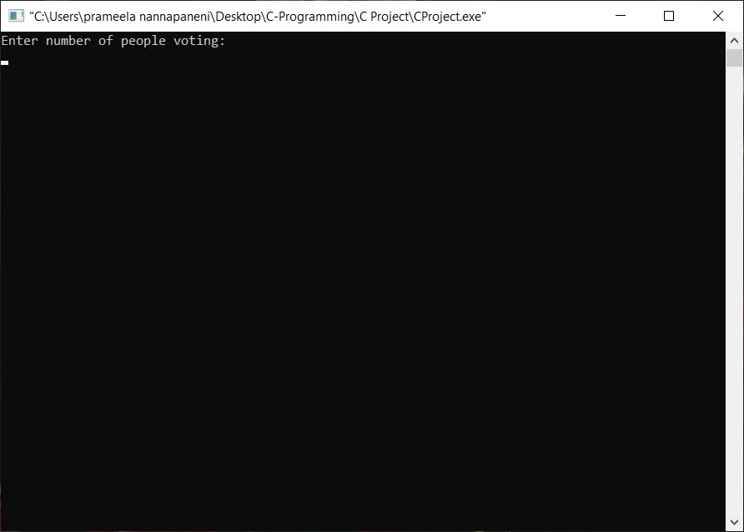

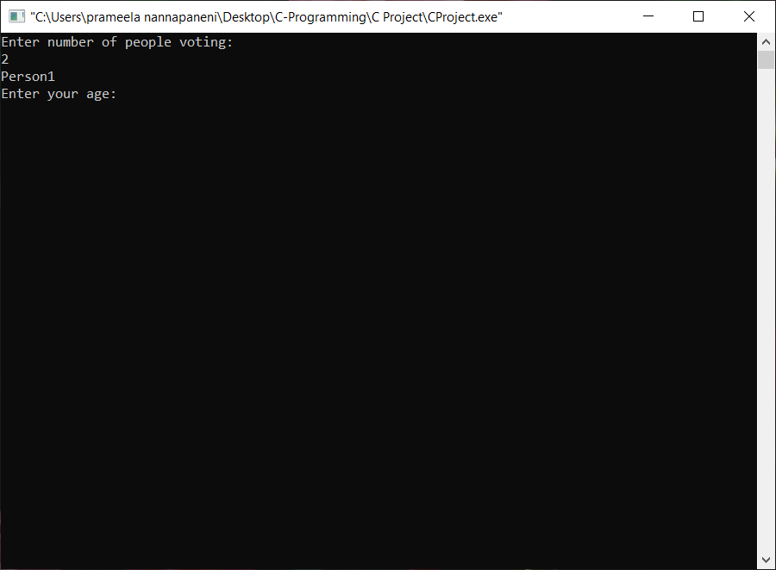

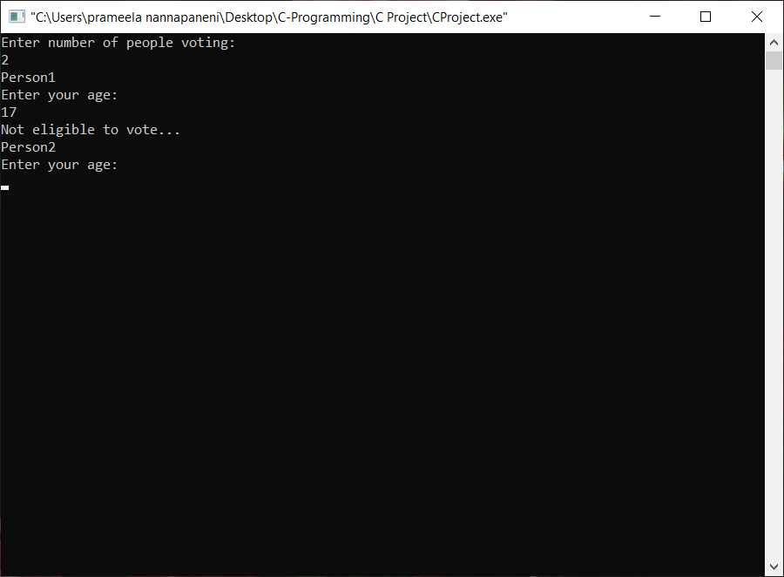

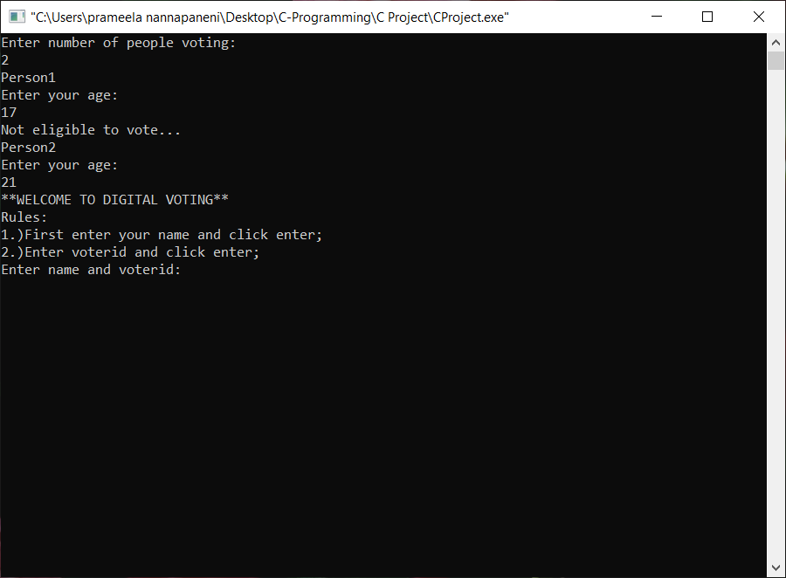

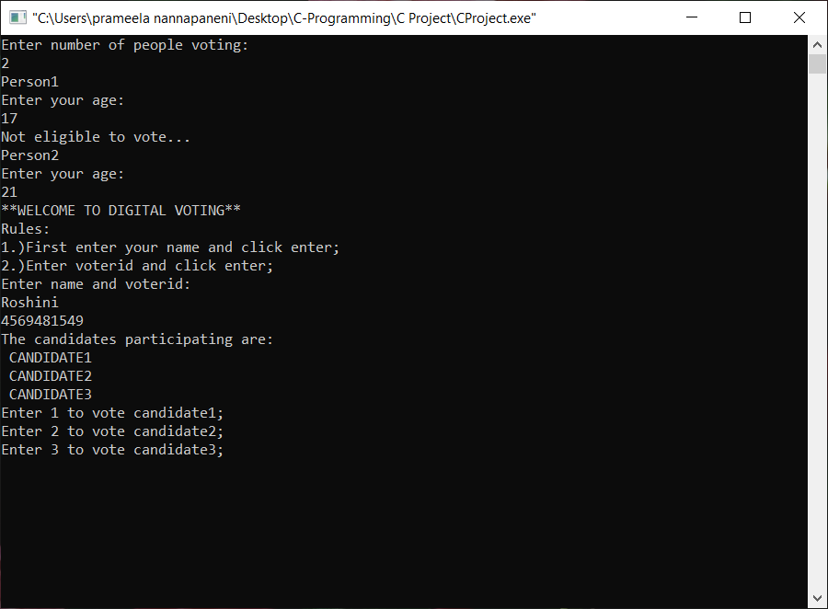

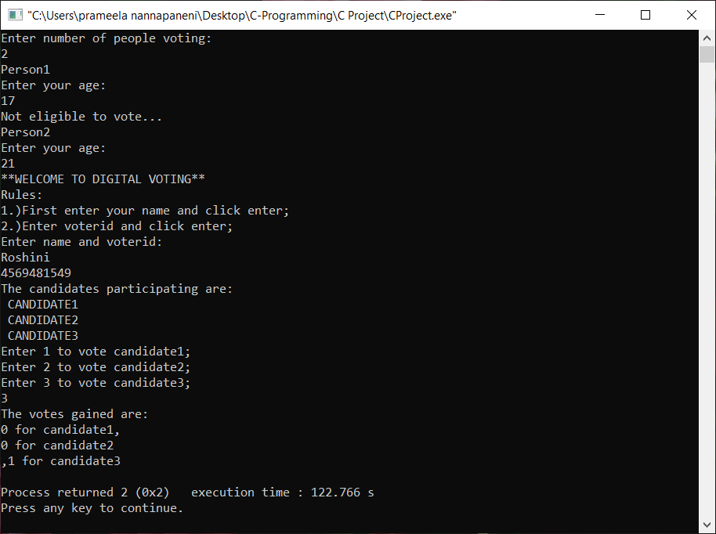

Flowchart:

Start

A=0,B=0,

C=0

Read no: of

people

i=1;

i<=no:of people;

true

Read age

false Age < 18

true

Read name,

voterid

Read vote

A B C

A ++ B++ C++

Print

votes

End

End user: This can be used to conduct elections. People

participating in voting will be the end user.

Conclusion: The overall project is useful to vote and follows a

systematic process. We learnt how to implement the

concept of structures and loops.